Game ideas:

1. The corrupt politician. Multiple choice story game
2. The town. Building and growth game.
3. Clock mechanic. Take apart and put back together a old style clock
4. Unique camera puzzle game. Use the multiple cameras in Unity to create disorienting puzzles.
5. Educational math/programming game.
6. Level Making game inspired by Turing Tumble. <https://upperstory.com/turingtumble/>
7. The corrupt politician: You are a corrupt politician, but so is your adversary. You will have no problems winning this election as long as you do not doing something horribly corrupt...  Problem is that if you get a chance to be corrupt, you have a hard time saying no... Multiple choice adventure with timed options. You only gain control of what to do after the politician has kicked the cat that was in his way and some kids took a picture, or after you have pulled your gun when finding your girlfriend in bed with someone else... Let the timer run out and your politician will make his piss poor choice so you better react before him!!

A reduced version that fits this project size:  
One scene with animations, and images. One scene with text only to show how we would continue the story.  
Challanges: A multiple choice system. Animations and images to make the story come to life. Being funny in writing...

2. The town. This was made before I read the midterm doc so it has to be made even simpler to fit the instantly playable attribute.

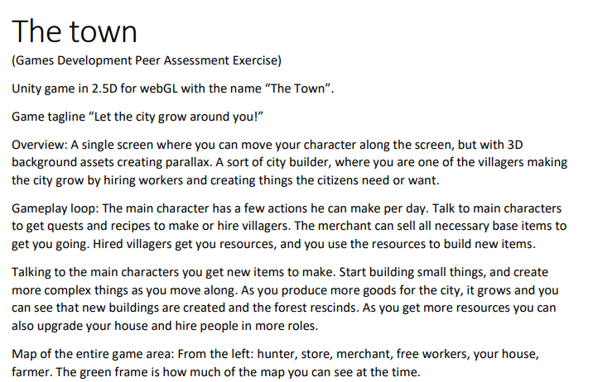

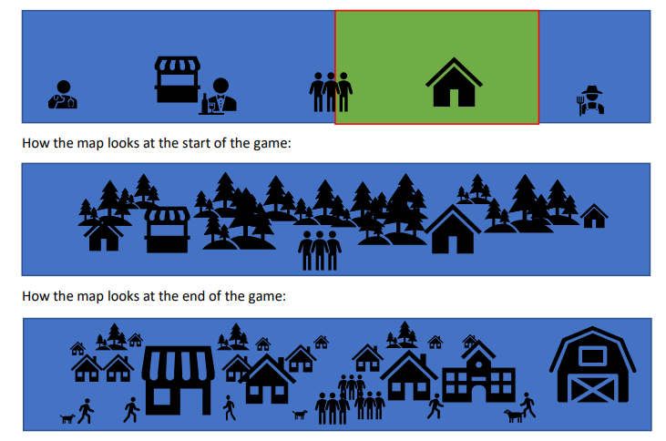

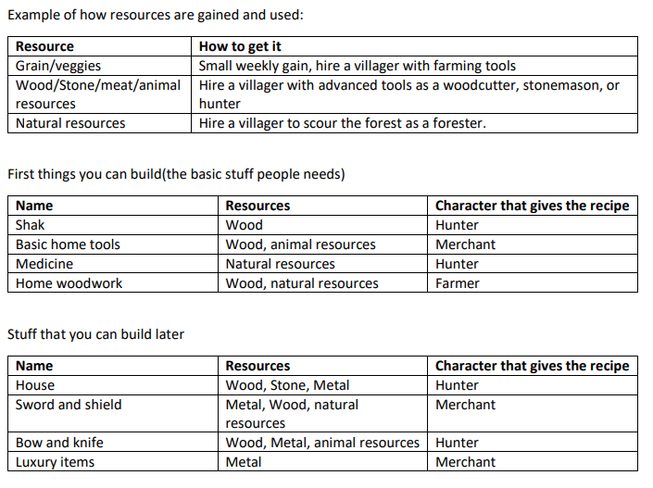

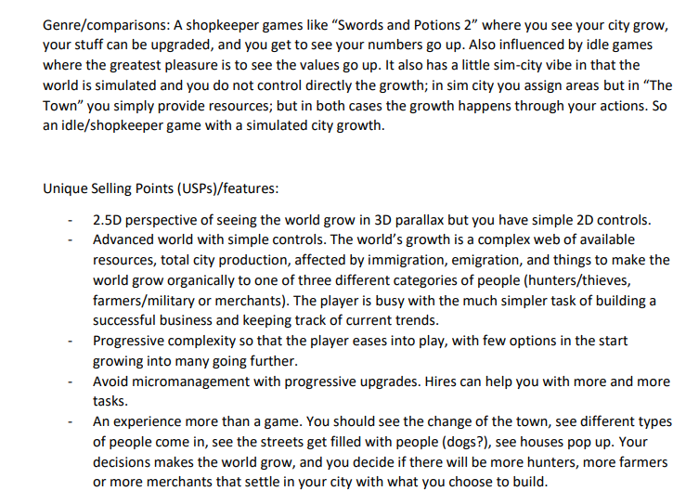

3. Clock mechanic  
We need a really good model for the inside workings of a clock. You take apart the pieces like in this game: <https://play.google.com/store/apps/details?id=com.nobleempire.wog&hl=en&gl=US&pli=1>  
A reduced version that fits this project size:  
Only one clock  
Challenges: Animation, getting the insides of the clock. I do not think we could model this ourselves in the time we have.

4. Unique camera puzzle game:  
The output of one camera can be the texture of a plane. With this we could build pieces of a view where you start with a simple task, like moving some blocks into place, but soon see more and more distorted versions of the playing field and have to puzzle them together in your mind.  
A reduced version that fits this project size:  
Three levels with progressively harder to orient puzzles.

5. Educational math or programming game:  
Some things are just taught better by a computer. For example math and programming. Get tasks, and direct feedback. For example teaching how negative numbers work for children.

6. Level making game inspired by Turing Tumble.  
My son loved this game... Why not create something similar on the computer. You could add a lot of the same ideas but expand with eternal balls and clear puzzles with a clear win state...